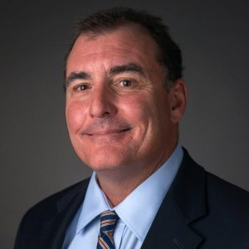
Daniel Levison, CEO
CRE Holdings
www.creholdings.co
Atlanta Investment Properties
Commercial Property Consultants
NAIOP, CCIM, SIOR, NAR

Mr. Levison’s commercial real estate career involves hands on experience collaborating with property owners, occupiers and investors spanning over four decades. Acting as a principal and broker he has been involved in over $100M of commercial real estate transactions through purchasing for his own account, and representing clients. During his career Mr. Levison has also been instrumental in creating multiple technology startups focused on commercial real estate all of which are still utilized in the industry today.

In 2020, Mr. Levison created Commercial Property Consultants to provide clients a personalized hand holding experience to guide them through the process of purchasing or disposing of their commercial real estate assets. Mr. Levison provides a unique perspective for his clients through having owned, renovated, repositioned, managed, marketed, and disposed of over $35M of commercial real estate for his own account.

Through a group strategic partners CPC has created a network of experts, available to CPC clients, who can assist in every facet of a business owners’ course of action - from positioning a company for growth, to providing access and advice for investment capital. CPC’s strategic partners can also provide expertise on developing business exit and wealth enhancement strategies from the sale of a business and/or real estate assets.

Mr. Levison has also created his own 501c3 charity ReStart3:20 focused on providing homes for homelessness veterans and supporting and teaching financial literacy classes to returning citizens being released from the Georgia Department of Corrections.

Mr. Levison resides in Sandy Springs with his wife Karen and yellow lab Rosie. They have four children, Turner, Taylor, Tate and Leah, and four grandchildren, Mia, Reese, Ella and Theo.

